
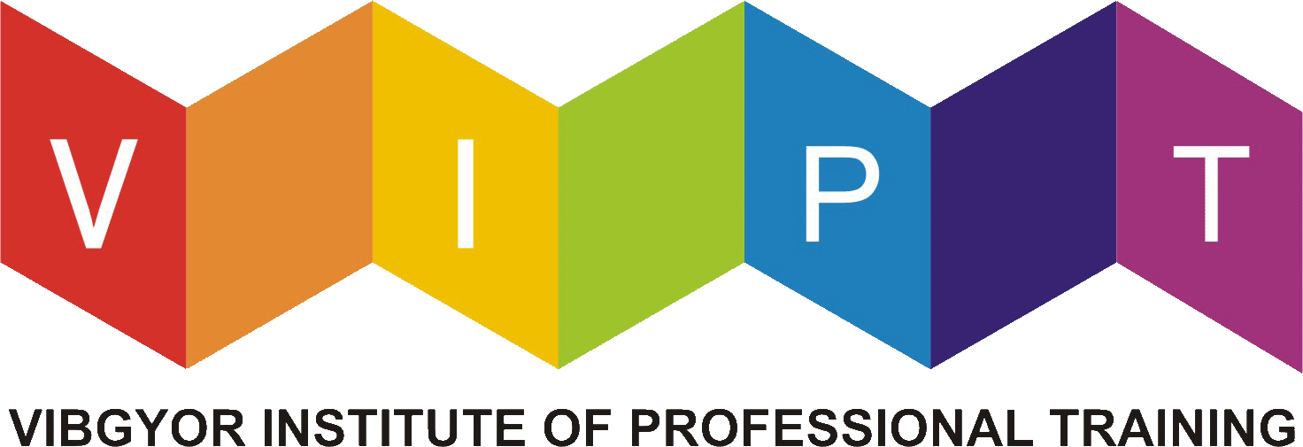

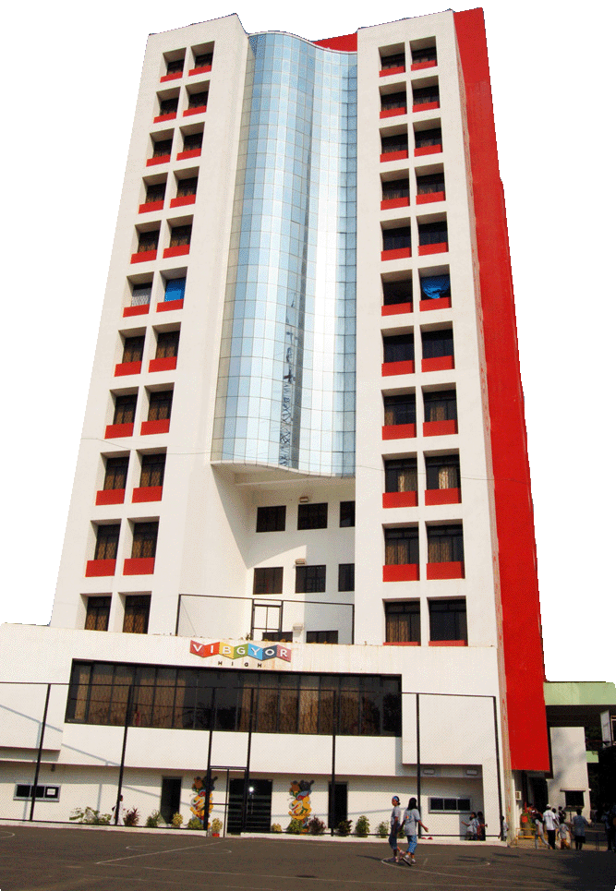
An Introduction

VIBGYOR Institute of Professional Training
Motilal Nagar 1, Srirang Sabde Marg,
Near Link Road, Goregaon (W), Mumbai – 400 104
Tel: 022 2879 1589, Mobile: 9833981495
Fax: 022 2875 0202
Web: www.viptindia.com
Email: rainings@vibgyorhigh.com


About us

VIPT is an organization that specializes in providing complete end-to-end training solutions for corporates across sectors in India. We, at VIPT are committed to discovering the innate talent and nurturing the inherent potential of each individual and making value addition to employees, who will be the leaders of tomorrow. We believe in building leadership skills by developing individuality and honing the potential in every employee. The focus is on making the task force independent decision makers, problem solvers and also on developing their emotional intelligence.

At VIPT, we believe in affecting people positively by empowering them in their personal, social and professional environment. Our aim is to increase the productivity of the organization and its performance. We have a team of experienced trainers who approach training with both knowledge and passion. We work with the client to identify individual and company-wide training needs and provide high quality training that will effortlessly transform employees at various levels in the hierarchy.

The training programs of VIPT encompass a wide range of skills that most organizations identify as an integral and necessary part of everyday business. In our quest to address every business training need, we offer a gamut of training programs that are aimed at achieving the desired results. Our approach to training and professional education includes experiential learning workshops, class-room training, seminars, webinars and the like. We also provide specialized “Train-the-trainer” courses and customized training material created to suit the needs of each organization. As a result, our clients see a measurable increase in employee retention, enhanced performance, customer satisfaction and revenues.

Each training program can be customized to meet your needs. We work with you to design a program that is relevant to your organizational growth. Each program is interactive, participatory and includes activities to ensure preparedness and reinforcement of concepts. Hence we say “We do not teach, we facilitate learning”

The VIPT WAY

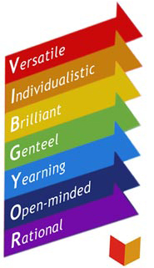

At VIBGYOR we revere & nurture these traits

The Institute, true to its name, stands for the radiance of the rainbow, which is endowed with the power to create, enrich and enlighten! We call it the place where the vibrancy of colours meets the splendour of achievement.

The transformation of the mascot -BO- the caterpillar into a beautiful butterfly is what the Institute envisages for every corporate aspirant.
VIPT aims at developing leadership skills and talent into saleable marketable skills that are required by the industry.

WE BRIDGE THE GREAT GAP BETWEEN EDUCATION & INDUSTRY EXPECTATIONS.

Vision

- To be acknowledged as one of the leaders in the Training industry by imparting quality training to individuals and organizations, and equipping them for a dynamically changing global economy
- To emerge as a dynamic, vibrant, value based learning organization comprising of exceptionally skilled, highly motivated and committed professionals who facilitate a holistic transformation of our trainees

Mission

- To assist organizations in increasing productivity and performance through their people
- Work with organizations to identify their individual and company-wide training needs and develop high quality training that will seamlessly transition their employees to a higher level
- Help organizations reach their milestones and goals by providing knowledge acquisition services
- Provide training solutions that match the expectations and requirements of Industry

WE Aim to:
- Help our students and trainees attain higher levels of knowledge and skills through quality training.
- Help organizations reach their milestones and goals by providing knowledge acquisition services.
- Provide training solutions that match the expectations and requirements of Industry.
- Provide our students and trainees with challenges and opportunities to succeed in a challenging environment.
We Believe in
- Complete transparency and provide comprehensive information about our content, fees, and instructors. We are one of the few companies that provide open access to our fee schedule, program outlines, etc.
- Quality and not quantity: Helping individuals determine whether a particular training course is the right solution for an individual or a group.
- Partnering with individuals and corporates to set goals and milestones for training.
- Giving personalized attention. Each of our programs is tailored to meet the specific needs of individuals and corporates.
- The 360 degree training cycle which involves training, practical application, evaluation, feedback and corrective training.
- Matching the right instructor(s) with the right group. Experience has taught us that compatability is a critical factor in the success of a training session.
- Building a long-term fruitful, mutually beneficial relationship with our clients.
- Having fun along the way to our goals.

At VIPT, our courses are designed to meet industry requirements.
Our 360 degree training approach equips participants with the skill to lead.

- Our training methodology is designed to help individuals at every level and thereby contribute at all levels of career development.
- Fresh candidates with no experience will be empowered with skills and knowledge that will help them get started in the industry of their choice.
- Experienced professionals are empowered to grow and move to the next level in the current organization by equipping them with the required skills sets.
- Leaders are empowered to lead and create a dynamic working environment, build teams, and create successful organizations.

Our Methodology

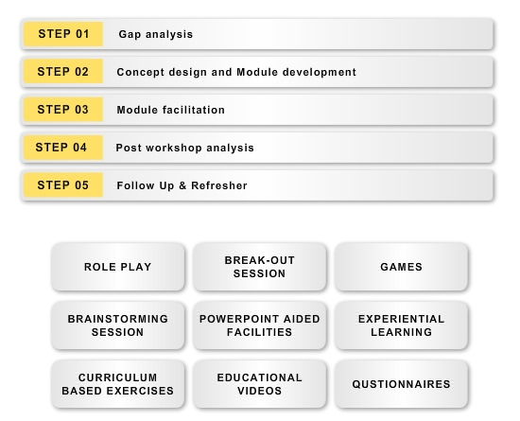

Our Infrastructure
VIPT has infrastructure in four Cities
- Bangalore
- Mumbai
- Pune
- Vadodara
Mumbai

Our strategic location near the BPO hub of Mumbai makes us a desired destination.
Our state of the art infrastructure is centrally air conditioned and is spread over 12,400 sq. ft. Each training room is spacious and is equipped with state of the art training tools. At VIPT quality is maintained through small batch strength which facilitates individual attention.

Pune

Located at NIBM, Road Pune, VIPT has a very picturesque hill as a backdrop, a spacious and airy lobby, artistically decorated craftwork in vibrant colours, We can boast of high standards of professionalism maintained by the management.

Vadodara

Situated on Padra Road, Vadodara in the lap of the lush, green and serene surroundings, VIPT presents the perfect learning environment for the future citizens of the country. The campus has residential facilities with centrally air-conditioned rooms and modern amenities.

Bengaluru

Located close to the upcoming exclusive enclaves of Brook Fields and White Fields in the Garden City the school is at Airport Whitefield Road, just 2km from Marathalli Bridge.

